**AIM :** To study and implement deployment of Ecommerce PWA to GitHub Pages.

# THEORY :

GitHub Pages is a web hosting service provided by GitHub, allowing users to host static websites directly from their GitHub repositories.

Key theoretical aspects and concepts related to GitHub Pages:

1. Static Websites: GitHub Pages is designed for hosting static websites, which means that the content of the website is fixed and doesn't change dynamically based on user interactions or server-side processing. This makes GitHub Pages ideal for blogs, portfolios, documentation sites, and simple informational websites.
2. Version Control: GitHub Pages integrates seamlessly with Git, the version control system used by GitHub. This allows developers to track changes to their website code, collaborate with others using branches and pull requests, and revert to previous versions if needed.
3. Branches: GitHub Pages can be configured to publish different branches of a repository. For example, the `master` branch is commonly used for the production version of the website, while other branches can be used for testing, development, or feature experimentation without affecting the live site.
4. Custom Domains: Users can map a custom domain (e.g., [`www.example.com`)](http://www.example.com/) to their GitHub Pages site, giving it a more professional and branded appearance. This

involves configuring DNS settings and updating the GitHub Pages settings accordingly.

1. Supported Technologies: GitHub Pages supports various technologies for building static websites, including HTML, CSS, JavaScript, and static site generators like Jekyll. This flexibility allows developers to choose the tools and frameworks that best suit their Needs.
2. Continuous Integration: GitHub Pages can be integrated with continuous

integration (CI) tools like GitHub Actions, allowing for automated testing, building, and deployment of the website whenever changes are pushed to the repository. This helps maintain a smooth development workflow and ensures that the live site is always

Up-to-date.

1. Free Hosting: One of the major advantages of GitHub Pages is that it provides free hosting for static websites, making it accessible to individual developers, small projects, open-source initiatives, and educational purposes without incurring hosting costs.
2. Community and Support: GitHub Pages is supported by a large community of

developers and has extensive documentation and resources available. This makes it easy for users to find help, troubleshoot issues, and learn best practices for optimizing their GitHub Pages sites.

By understanding these theoretical aspects, developers can effectively utilize GitHub Pages to host and manage their static websites, leveraging its features for version control, collaboration, automation, and cost-effective hosting.

Advantages of using GitHub Pages :

1. Free hosting for static websites.
2. Seamless integration with Git for version control.
3. Custom domain mapping and community support.

Disadvantages of using GitHub Pages:

1. Limited functionality for dynamic content.
2. Storage limits and dependency on GitHub's infrastructure.
3. Not suitable for large-scale applications with complex features.

Link to the GitHub repository : <https://github.com/suja1956/PWA_Project/tree/main> Hosted website link : <https://suja1956.github.io/PWA_Project/>

GitHub pages Screenshot :

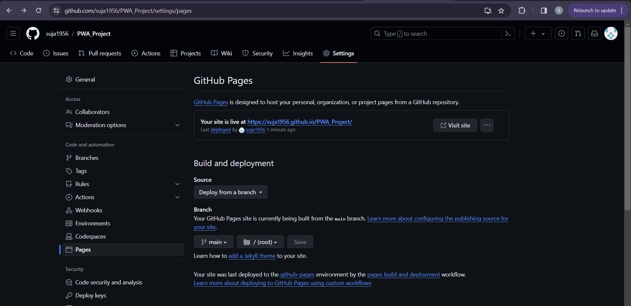

# Hosted website Screenshots:



**CONCLUSION :**

Hence we have understood how to deploy our E-commerce Progressive web application via Github pages and understood the working of GitHub pages.